Creating a PCIe Root Complex in a Zynq Ultrascale+ mpsoc FPGA

Introduction to the PCIe protocol

A PCIe subsystem is used for high speed communication between a host and various peripheral devices. It is composed of:

- Host
Usually a CPU that needs fast access to various peripheral devices
- Device Memory
The DDR memory of the Host
- Endpoint Devices
The individual devices in the system the host needs to access
- Root Complex
The core of the PCIe system linking everything together

The desired functionality of the PCIe system is to allow:
1.The host to send messages to the endpoints
2.The host to read or write from the memory and memory mapped registers of the Endpoint Devices

Note the PCIe standard does not specify the number of root complexes a system has (and likewise linux adds no such limitation) but 99.9% of systems only have 1 root complex.

The root complexes first role is to add as a DMA interfacing between the PCIe messages and DDR memory to enable point 2, that is the host can orchestrate memory transfers between the endpoint devices and the device memory via the root complex. The root complex serves the transfer and also serves as a translation layer between the PCIe world and the memory bus world. In the case of FPGAs, a third abstraction layer is added in the form of AXI memory busses and the root complex translates and orchestrates between the PCIe world and the AXI world.

To control the root complex, multiple memory fields exist. First there is the control memory field which is used for setting the parameters of the root complex and also for the host to tell the root complex to send a particular message to an end point. There are also BAR regions, 1 for each endpoint device with a memory or memory mapped registers. Writing to a BAR region causes the root complex to write to that address within the memory of the targetted endpoint device. Optionally, a host may add bar regions in its own device memory which enable the endpoints to write to that memory region without needing the CPU to orchestrate it if bidirectional communication is desired.

Between the root complex and the endpoints are PCIe lanes. Each root complex has a specified number of PCIe lanes (usually there are 16 in normal CPUs and up to 64 in servers). These lanes can either be directly connected to an endpoint or be connected via a PCIe switch to multiple end points. However only one endpoint device may use a lane at once so if a switch is used, the root complex or endpoint must first allocate the lane before using it. If the lane is taken it must wait so when possible it is best to prevent lane sharing.

Limitations with Ultrascale + FPGAs
Depending on the standard different lane speeds may be used. PCIe 1.0 allows for up to 2.5Gbps/lane, PCIe 2.0 for 5Gbps/lane, PCIe 3.0 for 8Gbps/lane. Ultrascale+ FPGAs support up to PCIe 3.0 (some speed grades do not support all of them though, but the sidewinder ones with -2 do) though the pcie wires between the FPGA and the endpoint must also be of that standard or greater. PCIe 4.0 (16Gbps/lane) and PCIe 5.0(32Gbps/lane) also exist but they are not supported by any Ultrascale+ FPGAs.

Building the root complex

The DMA/Bridge Subsystem for PCI Express can be configured to become a root complex. In this tutorial we will build a root complex connected to a single NVMe SSD connected by a 4 lane PCIe 2.0 link to the FPGA. We add this IP and configure it as follows:
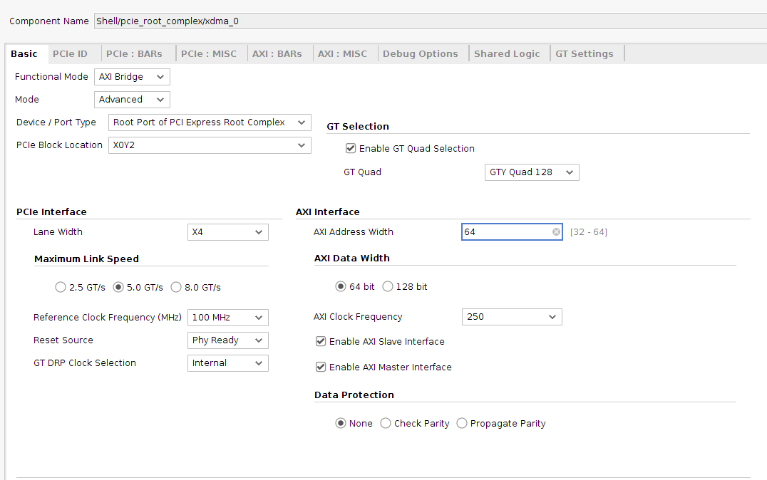
The functional mode is set as an AXI Bridge since it contains the host bridge. The mode is advanced for all config options. The device type is root port of PCI Express root complex as expected. The PCIe Block location can be optained in the user guide of the board you are using. In this case we are connected to the NVMe 2 port of the sidewinder 100 Board which is connected to GTY Quad 128 and PCI block location X0Y2. We use PCIe 2.0 so the link speed is set as 5.0GT/s. The reference clock is also given by the board which in this case is 100MHz. PHY Ready tells the board to make the block active even when the PCIe is not configured which is important since the block is what configures the PCIe (chicken and egg problem). We use the internally created DRP clock and we configure the AXI to suite our environment. We can balance clock frequency with data width, all configurations here are valid. Data protection is allowed by some Endpoints but our particular SSD doesn’t support it.

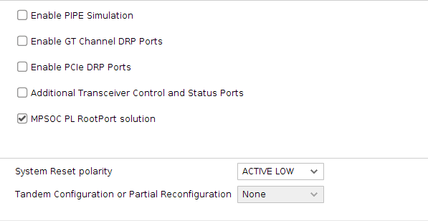

At the bottom of the Basic Window we select the MPSOC PL RootPort solution which is a patch released for MPSOC devices since Xilinx accidentally wired the PCIe backwards on them (oops). Make sure you use Vivado 2018 or greater with this fix. The system polarity is of whatever reset you use. Here we use the reset from the ARM which is Active Low

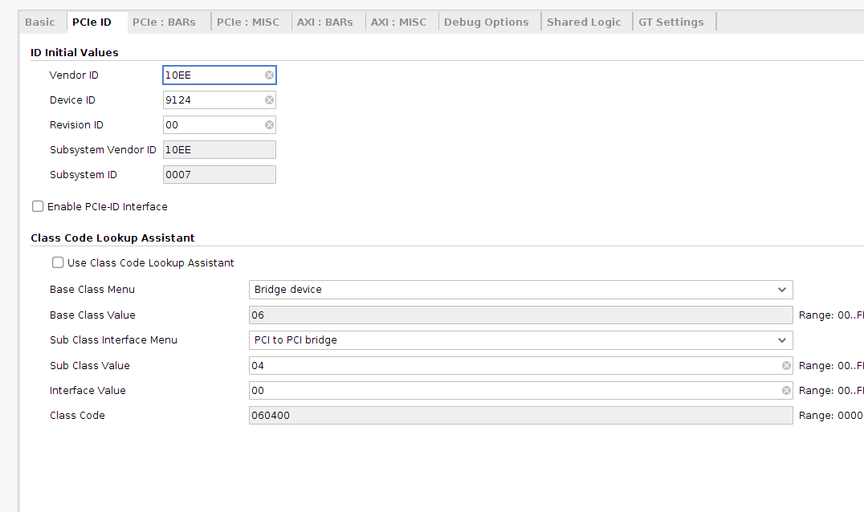
In the PCIe ID tab we set the vendor and device ID. These do not affect operation but Xilinx has Vendor ID 10EE so if you use it it appears as a Xilinx device. Device ID can be anything but must be unique if multiple root ports exist. The Class Code is for a bridge PCI to PCI bridge (since it is bridging from the ARM driver to the PCI world) which is code 060400. This must match.

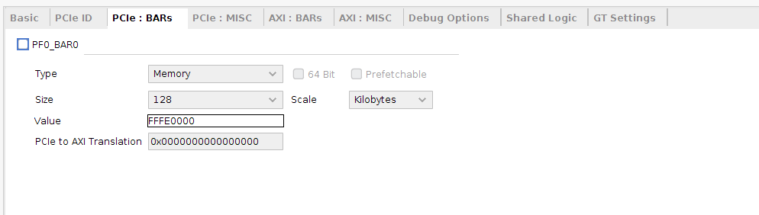
No PCI:BARs are used since SSDs do not require a region in the host memory space to function

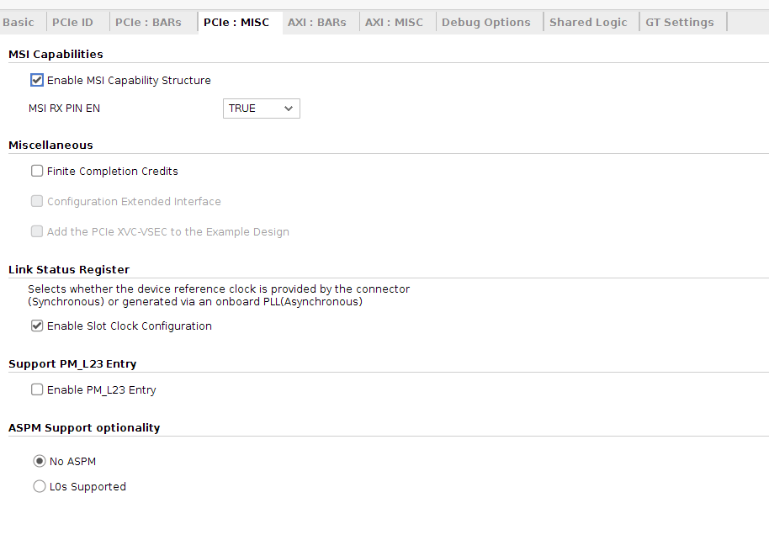
MSI capability is needed for linux PCIe drivers so select it. We provide the reference clock which is synchronized to the NVMe clock for ideal performance. PM_L23 and ASPM are not needed for this application
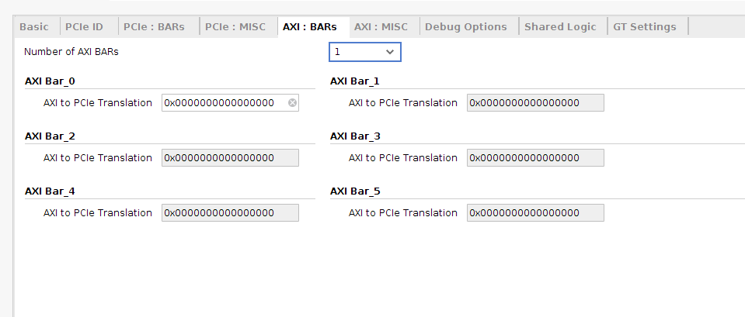
If the root port is connected to multiple endpoint devices, we can partition the BAR address of the root port between the various devices. Here we set the offset of each device’s memory field. In this case we only have one endpoint connected to the root complex so we can use the offset of 0 to give it the entire BAR space.

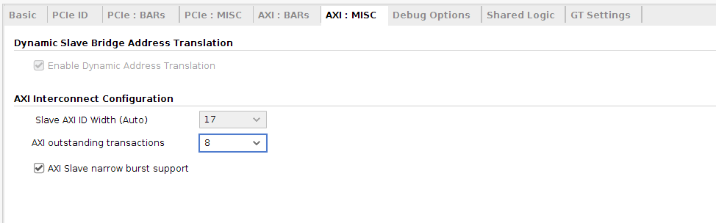
We can balance max outstanding transactions, higher values mean better performance but more buffering needed. We set it at the max value here. We also allow narrow bursts which enable small writes and reads to be possible.
Debug Options are not necessary but can be added if desired
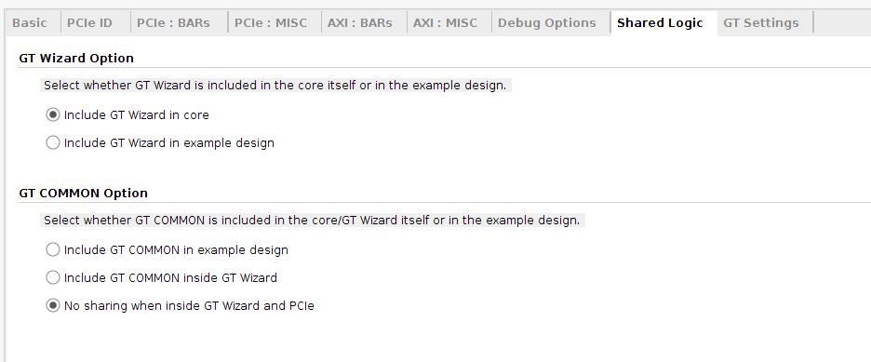
We put the GT Wizard in the core itself so we don’t have to build it outside. Since it is not being used for other blocks, we don’t need sharing.

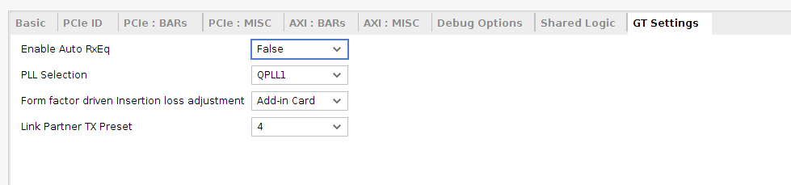
Receiver equalization is not needed for this project. We can select which PLL we are using and we can select where the endpoint is. This determines how much loss the system expects used for redundancy calculations. In our case the SSD is an ADD in card. I am not sure what the link partner TX Preset is but the documentation tells us to set it to 4.

Connecting the core
We have elected to add a CDMA to this project. The CDMA is fully optional and not required but helps significantly with performance. A CDMA consists of an AXI FULL Master and AXI Lite Slave. Based on instructions in the AXI Lite port, the CDMA can copy a chunk of memory from one address to another. In PCIe, most of what we will do is copy data between the device memory and the BAR address. By using a CDMA none of this data needs to be copied back to the processor and it can simply orchestrate transfers. Note the NVMe driver will automatically use the CDMA if it sees it in the device tree for its transfers.

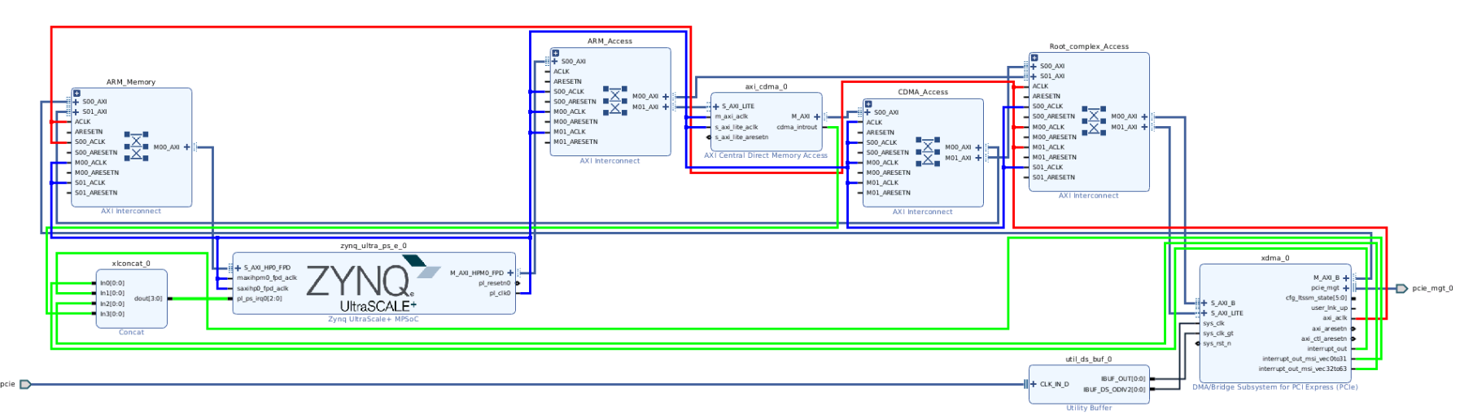

The root complex is connected as shown above. The S_AXI_LITE port is used for the control region and the S_AXI_B port is used for the BAR address (to write to the memory regions of the endpoints). They are connected to the root complex access interconnect. The master port is used to write to the device memory and so it is connected to the ARM Memory interconnect that accesses the Zynq Memory. Root Complex Access is accessible by both the CDMA access and ARM access interconnects which provide access to the CDMA and ARM respectively. The ARM Access also lets the ARM control the CDMA and the CDMA Access gives the CDMA access to the ARM’s memory as well. The clocks are also shown with the 250MHz PCIe generated clock shown in Red and the 100MHz ARM generated clock shown in Blue. The XDMA and CDMA both generate interrupts shown in green. The mapping of those interrupts is arbitrary but to match with the provided device tree the following mapping should be followed. A concat is used to concatenate the various interrupt signals to a single line:
pin 0 – XDMA Interrupt out
pin 1 – XDMA MSI Vector 0 – 31 interrupt
pin 2 – XDMA MSI Vector 32 – 63 interrupt
pin 3 – CDMA Interrupt

The XDMA also requires a clock synchronized with the NVMe. For this we refer to the board’s user guide to find the pins for this clock. We will constrain the port to use AB34 and AB35 as per the manual. We also constrain the clock to have a 10ns period. The insert in the constrain file is shown below alongside the entry in the user manual.
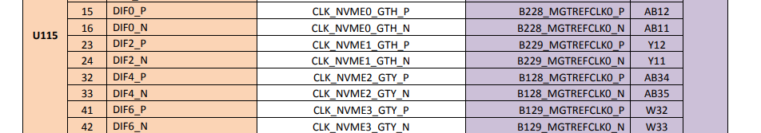

We also use a utility buffer in IBUFDSGTE mode to separate this clock into the clock for the gt (UTIL_BUF/IBUF_DS_OUT -> XDMA/sys_clk_gt) and for the reference system clock (UTIL_BUF/IBUF_DS_ODIV2 -> XDMA/sys_clk). The reset input to the XDMA can be asynchronous so any external reset signals can be used. In this case we used the ARM generated reset.
Lastly we connect the pcie_mgt port to an external interface port. This port is automatically constrained by Vivado depending on the GT Quad choice and therefore requires no entry in the user constrain file.
Linux Config
Once the bitstream is generated, we need to tell linux the configuration parameters of our root complex so that it can be scanned and enumerated. Then we need to mount the SSD to the Linux file system. For providing the parameters, a device tree overlay is used. The one below works for this project and it is commented to allow the user to configure it as desired. The address mapping is also shown

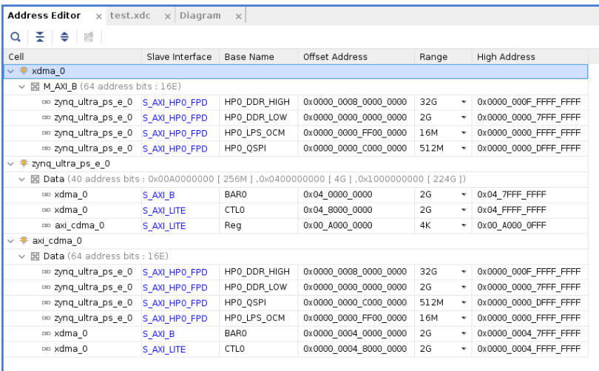

/dts-v1/;
/plugin/;
/ {
fragment@0 {
//Fragment 0 loads the bitstream to the fpga
target = <&fpga_full>;
overlay0: __overlay__ {
#address-cells = <2>;
#size-cells = <2>;
firmware-name = "<project_name>.bin"; //set the name of the bin file containing the bitstream
resets = <&rst 116>;
};
};
fragment@1 {
//fragment 1 declares the 100MHz clock calling it fclk0
target = <&fclk0>;
overlay1: __overlay__ {
status = "okay";
#clock-cells = <0>;
clock-frequency = <99999001>;
compatible = "fixed-clock";
};
};
fragment@3 {
//fragment 3 tells linux the location and parameters of the CDMA and root complex.
target = <&amba>;
overlay3: __overlay__ {
Shell_pcie_root_complex_axi_cdma_0: cdma@a0050000 {
#dma-cells = <1>;//we create a cdma
clock-names = "m_axi_aclk", "s_axi_lite_aclk"; //State the two clocks and their frequency
clocks = <&fclk0>, <&fclk0>;
compatible = "xlnx,axi-cdma-4.1", "xlnx,axi-cdma-1.00.a";//Launch CDMA drivers in Linux
interrupt-names = "cdma_introut";
interrupt-parent = <&gic>;
interrupts = <0 92 4>;//Hardware interrupts start at 89 in ultrascale, 89 + 3 = 92
reg = <0x0 0xa0050000 0x0 0x10000>; //<CONFIG_ADDR_HIGH CONFIG_ADDR_LOW CONFIG_SIZE_HIGH CONFIG_SIZE_LOW>
xlnx,addrwidth = <0x28>; //Address width of CDMA
dma-channel@a0050000 {
//Declare the dma channel we use with the CDMA
compatible = "xlnx,axi-cdma-channel";
interrupts = <0 92 4>;
xlnx,datawidth = <0x80>;
xlnx,device-id = <0x0>;
xlnx,max-burst-len = <0x4>;
};
};
Shell_pcie_root_complex_xdma_0: pcie@480000000 {
#address-cells = <3>;
#interrupt-cells = <1>;
#size-cells = <2>;
compatible = "xlnx,xdma-host-3.00";//Launch the PCIe driver
device_type = "pci";
//Interrupt map and mask
interrupt-map = <0 0 0 1 &pcie_intc_0 1>, <0 0 0 2 &pcie_intc_0 2>, <0 0 0 3 &pcie_intc_0 3>, <0 0 0 4 &pcie_intc_0 4>;
interrupt-map-mask = <0 0 0 7>;
interrupt-names = "misc", "msi0", "msi1";
interrupt-parent = <&gic>;
bus-range = <0 255>;
interrupts = <0 89 4 0 90 4 0 91 4>;//HW interrups 0 1 and 2 + 89 (89 is the start of hardware interrupts in linux)
ranges = <0x02000000 0x00000000 0x00000000 0x00000004 0x000000 0x00000000 0x80000000>;//<MODE0 MODE1 MODE2 BAR_HIGH_ADDRESS BAR_LOW_ADDRESS BAR_SIZE_HIGH BAR_SIZE_LOW>
//HIGH and LOW refer to top and bottom 32 bits respectively as device tree properties are 32 bits in size
reg = <0x00000004 0x80000000 0x0 0x80000000>;//<CONFIG_ADDR_HIGH CONFIG_ADDR_LOW CONFIG_SIZE_HIGH CONFIG_SIZE_LOW>
pcie_intc_0: interrupt-controller {
#address-cells = <0>;//Launch the interrupt controller needed by PCIe
#interrupt-cells = <1>;
interrupt-controller ;
};
};
};
};
};
Running lspci and lsblk gives us the following
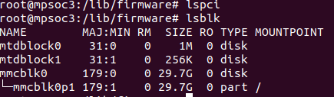

We then load the device tree above which programs the Linux and running those commands gives us
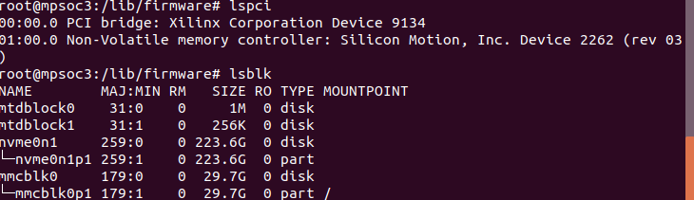

The NVMe device is visible now. To initialize it, we re-enumerate the PCIe by echoing 1 to the character device /sys/bus/pci/rescan. Note, Linux actively scans and it is possible the NVMe is not visible until the rescan happens. Then we can mount it using mount /dev/<device name in this case nvme01n1p1> <base_directory_of_ssd>. (e.g. mount /dev/nvme0n1p1 /media/nvme/). At this point the SSD is ready to be used and fully linked with the linux drivers.

